Question : 1
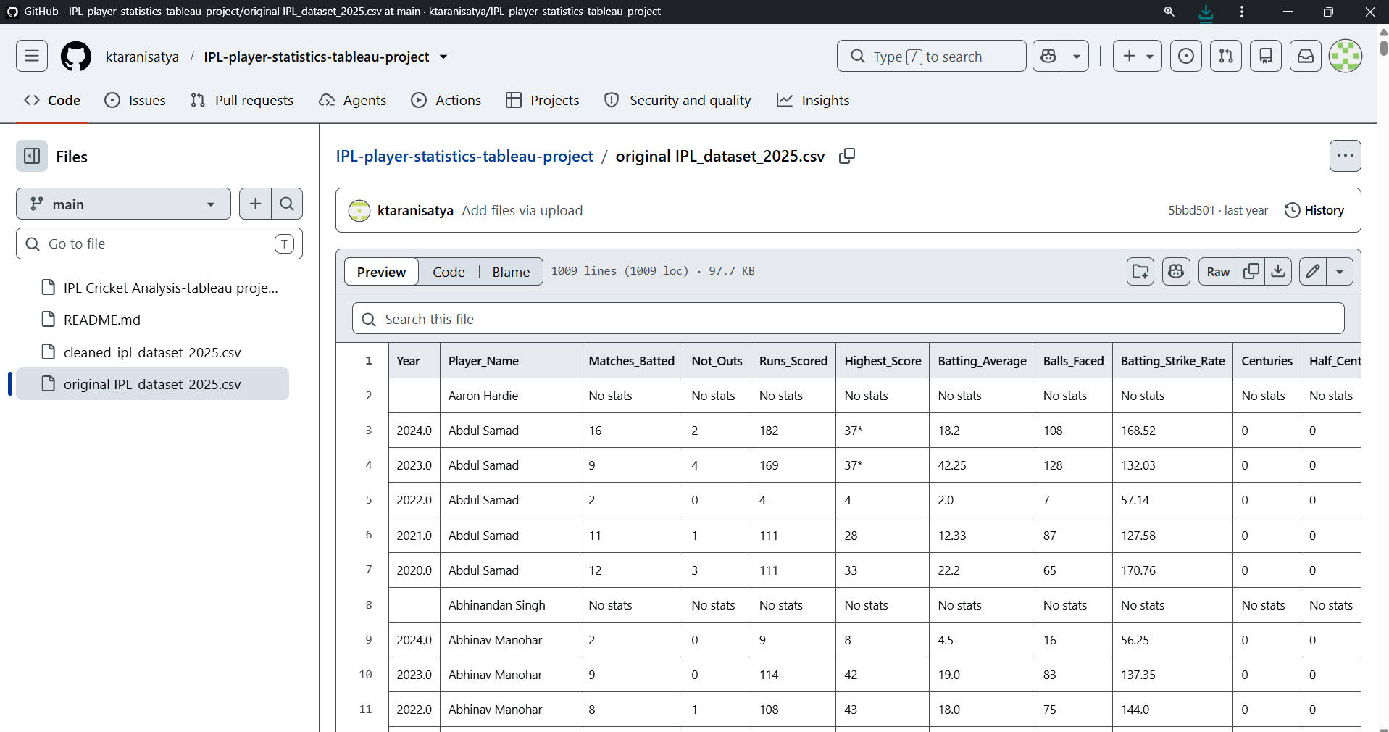
Download a sample CSV file of IPL player stats (include columns like player name, runs, matches, and some missing values). Load it into a pandas DataFrame and use isnull() and notnull() to print how many missing values are present in each column :

import pandas as pd
df = pd.read_csv("Lib/original IPL_dataset_2025.csv")
print("Missing values:")
print(df.isnull().sum())
print("\nNon-missing values:")
print(df.notnull().sum())

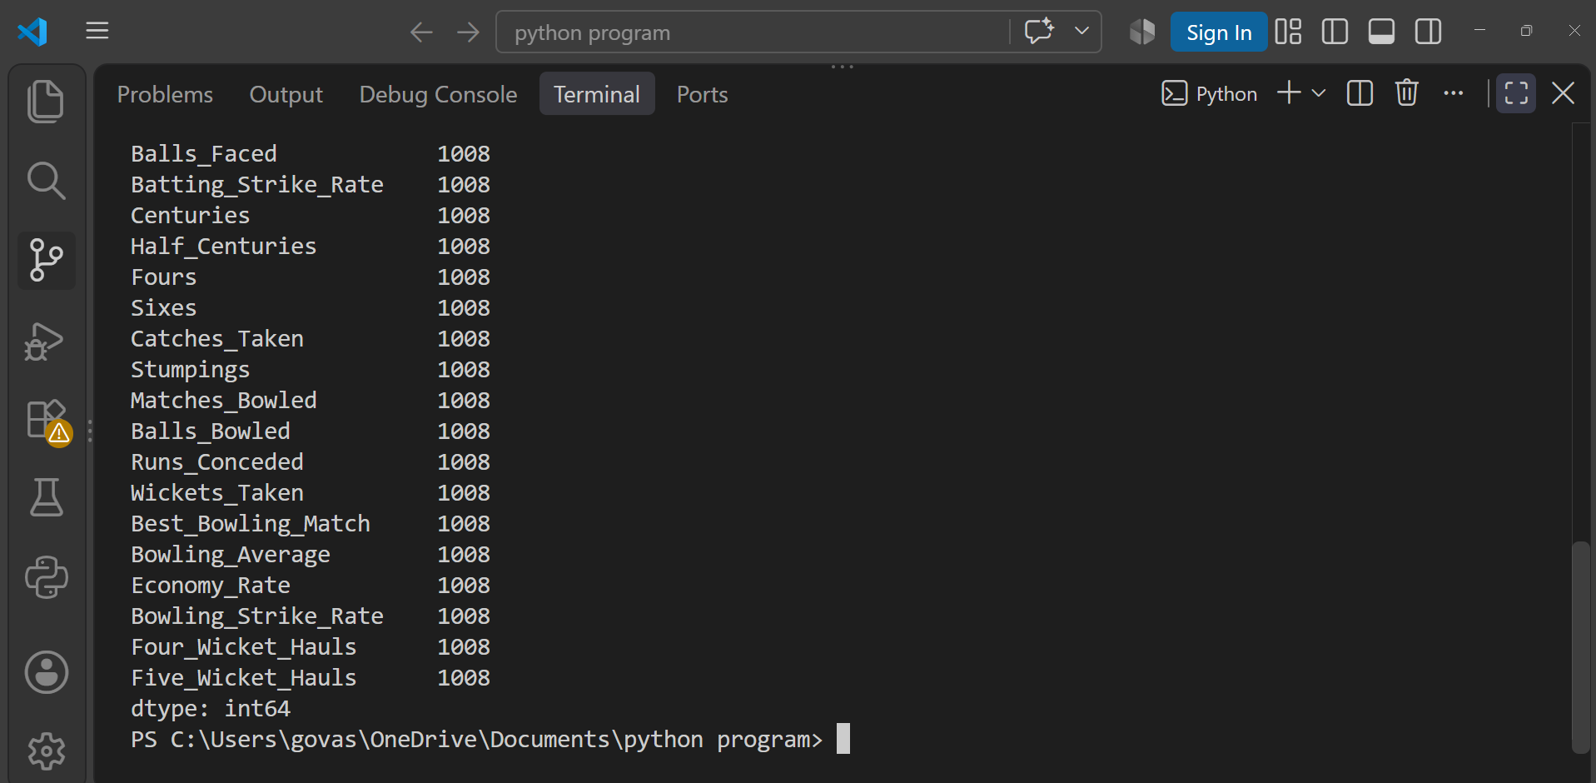
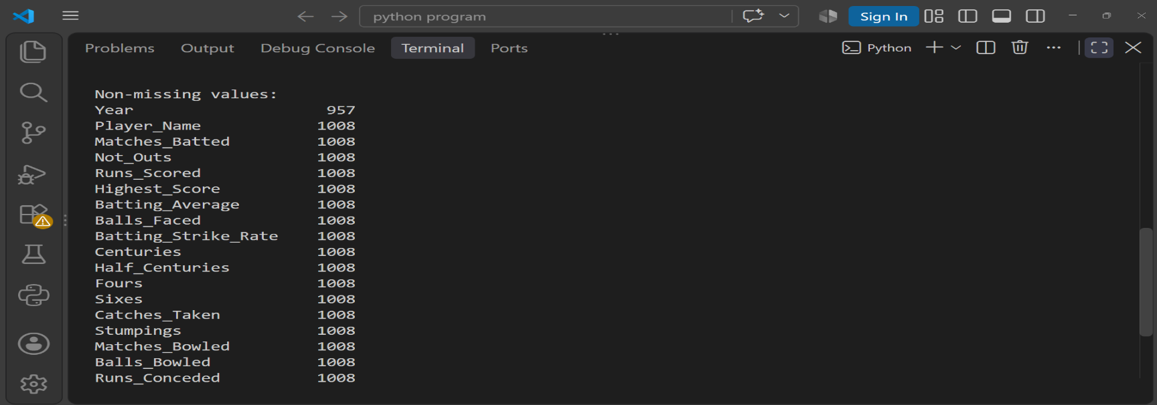
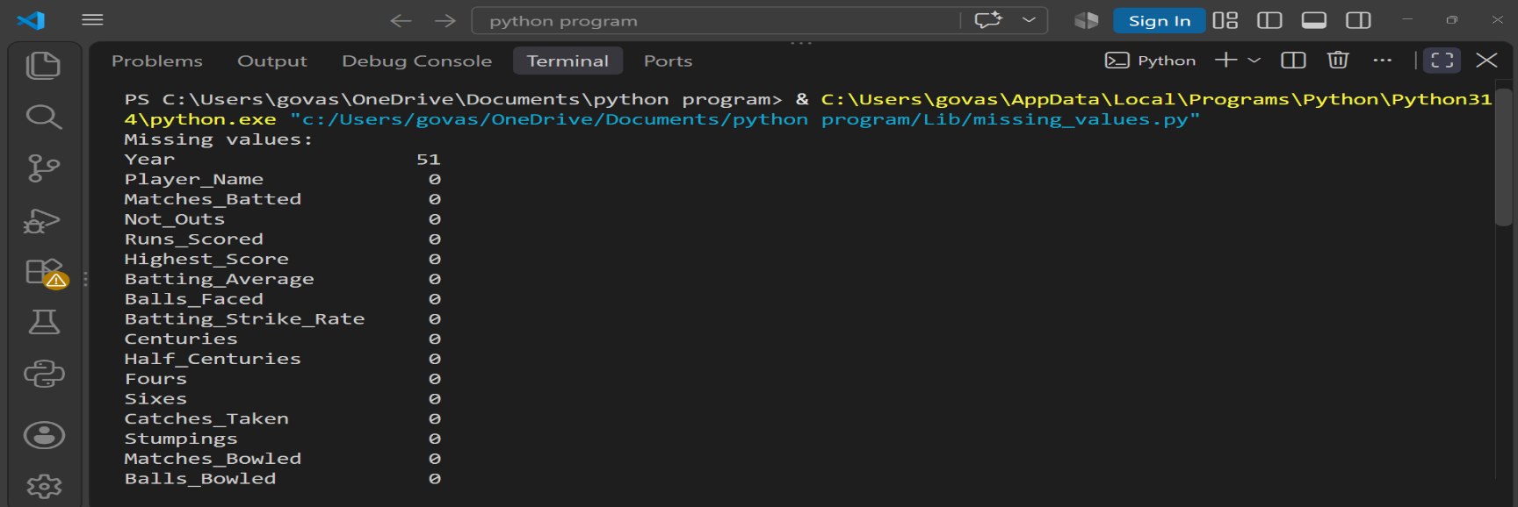
Question : 2
Using the loaded IPL player stats DataFrame, apply dropna(axis=0, how='any') to remove all rows with any missing data and display the shape of the DataFrame before and after dropping :

import pandas as pd
df = pd.read_csv("Lib/original IPL_dataset_2025.csv")
print("Shape before dropping:")
print(df.shape)
df_clean =df.dropna(axis=0, how='any')
print("\nShape after dropping:")
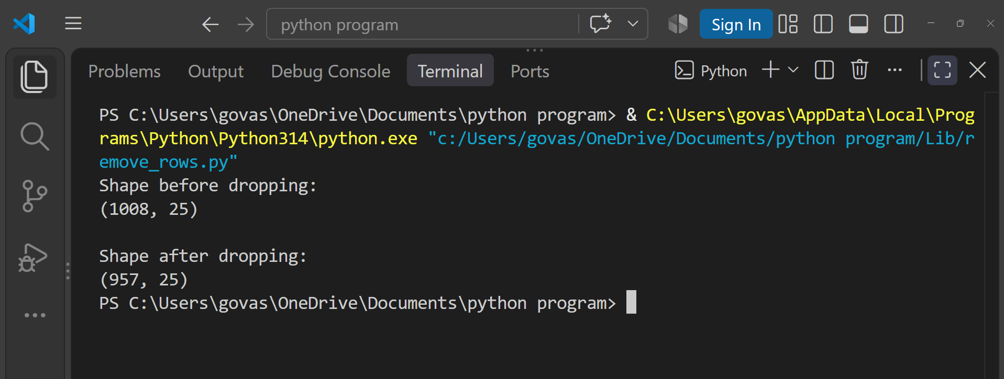
print(df_clean.shape)

Question : 3
For the 'runs' column in your IPL player stats DataFrame, use fillna() to replace missing values with the mean of the column. Print the updated column to verify the changes :

import pandas as pd
df = pd.read_csv("Lib/original IPL_dataset_2025.csv")
df["Runs_Scored"] = pd.to_numeric(df["Runs_Scored"], errors="coerce")
mean_runs = df["Runs_Scored"].mean()
df["Runs_Scored"] = df["Runs_Scored"].fillna(mean_runs)
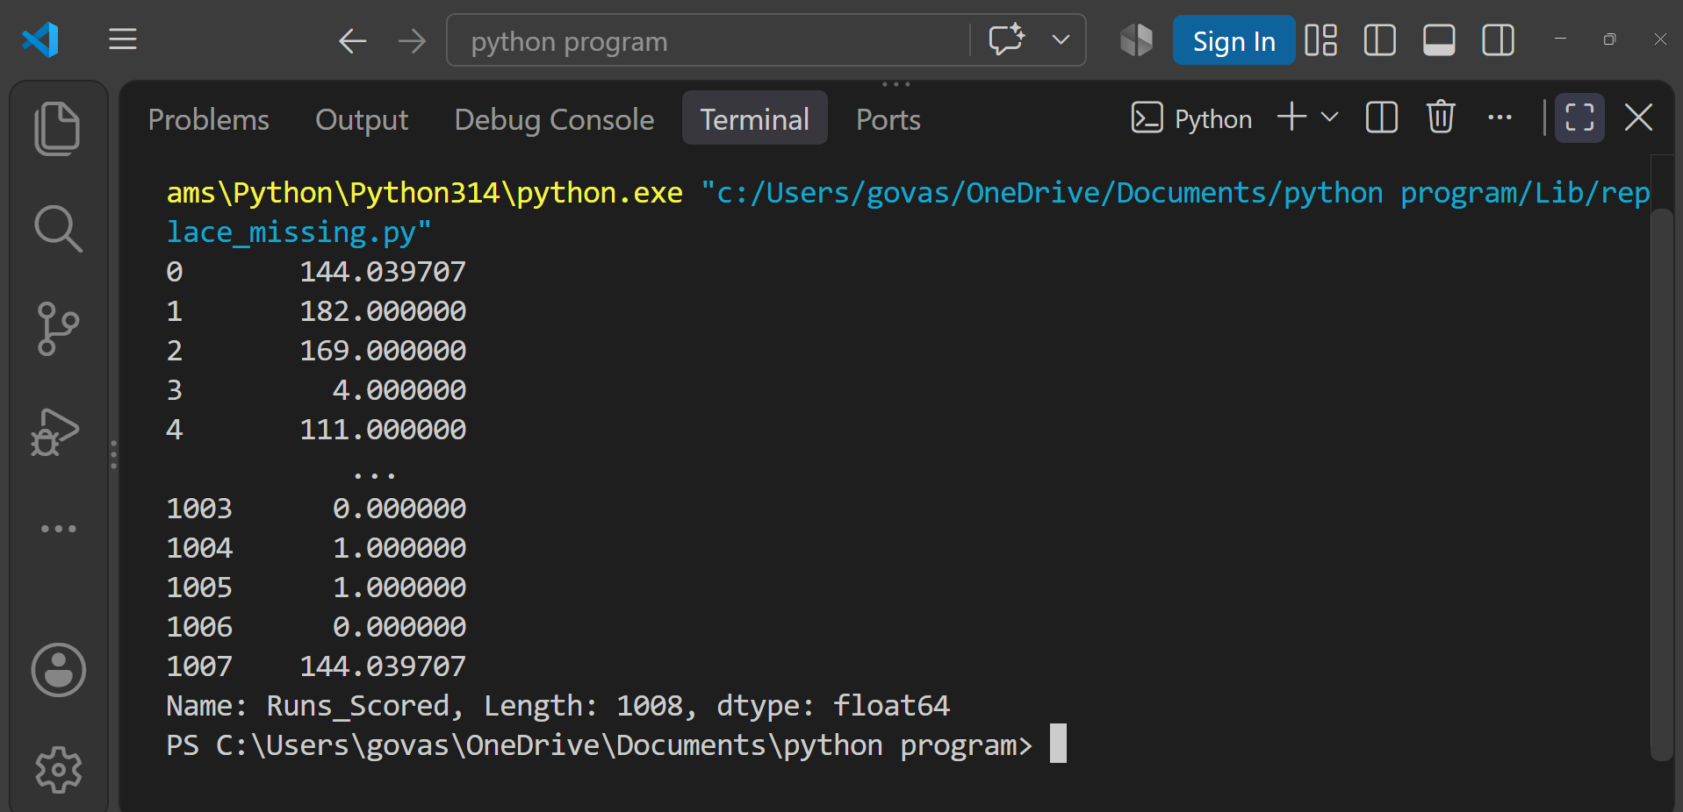
print(df["Runs_Scored"])

Question : 4
Simulate a Zomato-style restaurant ratings dataset with some missing ratings. Use forward fill (method='ffill') to fill missing values in the ratings column, then use backward fill (method='bfill') for any remaining missing values. Show the before and after results :
import pandas as pd
df = pd.DataFrame({
"restaurant": ["Restaurant A","Restaurant B","Restaurant C","Restaurant D","Restaurant E"],
"rating": [4.5,None,None,4.2,None]
})
print("Before filling:")
print(df)
df["rating"] = df["rating"].ffill()
df["rating"] = df["rating"].bfill()
print("\nAfter filling:")
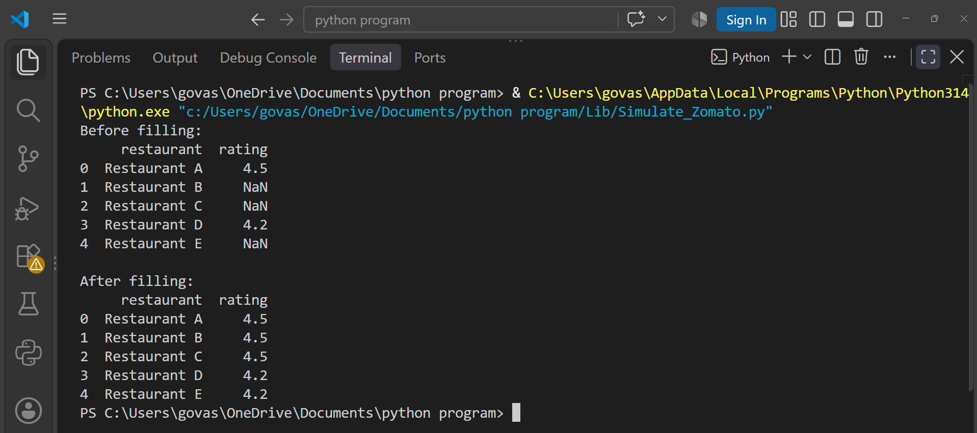
print(df)
Question : 5
Pick any one column with missing values from your dataset and explain which missingness mechanism (MCAR, MAR, or MNAR) is most likely and why, using 2-3 sentences.<br><br><em><strong>Hint:</strong> Think about whether the missing data is random or related to other factors in the dataset : </em>

The Year column in the IPL dataset has some missing values. The missingness is most likely MCAR (Missing Completely At Random) because the missing values do not appear to depend on other variables in the dataset. There is no clear pattern showing that the missing Year values are related to a player's runs, matches, or other statistics.

